# Exercises: Introduction to CSS

## Reversed List

Create a Web Page like the following:

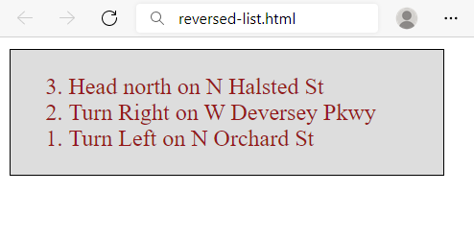

Create two files: reversed-list.htmlandreversed-list.css.

## The Modern JavaScript

Create a Web Page like the following.

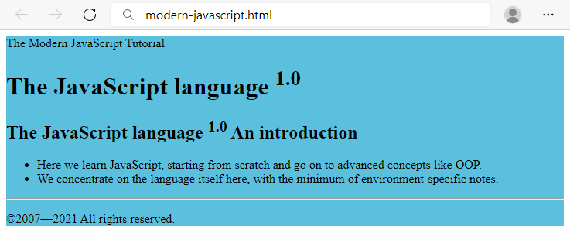

Create two files: modern-javascript.html and modern-javascript.css.

## Book Story

Create a Web Page like the following. Set the html title to be the same as the task name.

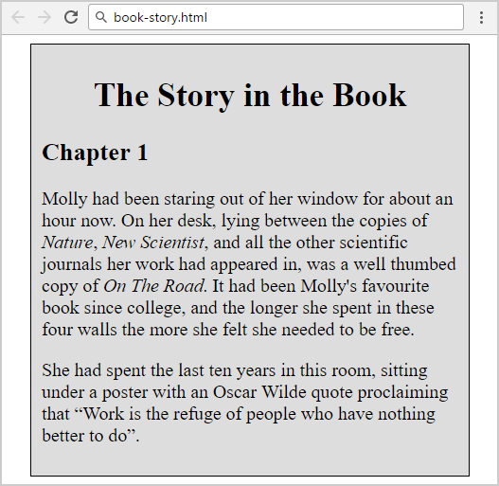

Create two files: book-story.htmlandbook-story.css.

## World Cup News

Create a Web Page like the following.

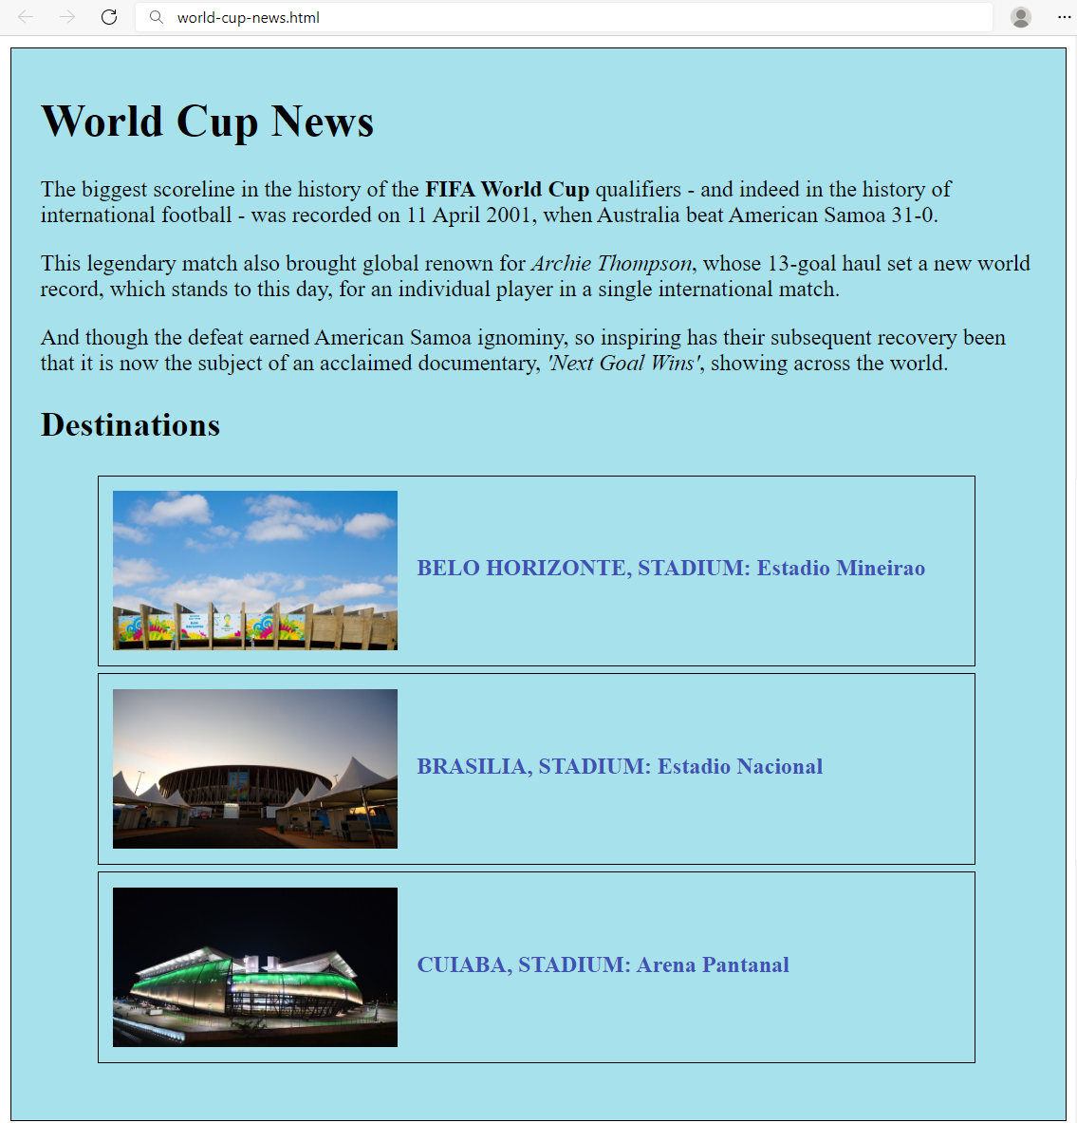

Create two files: world-cup-news.html and world-cup-news.css.

## Restaurant Menu

Create a web page like the following:

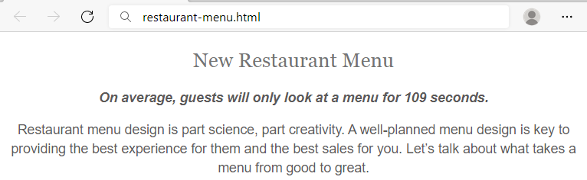

## Style Lists

Create a web page like the following:

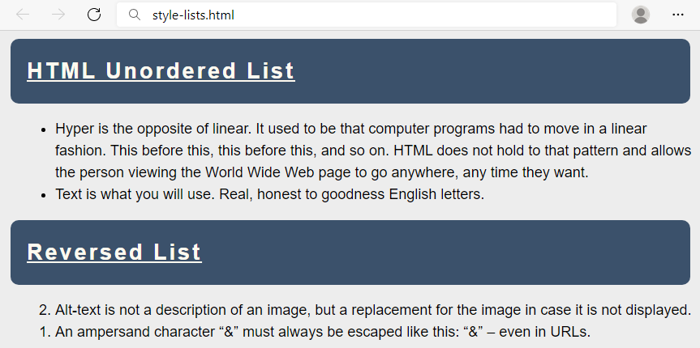

## Styling Tables

Create a web page like the following:

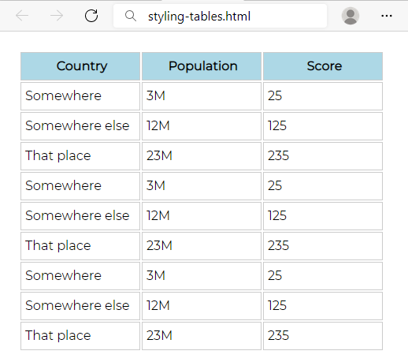

## Buttons CSS

Create a web page like the following:

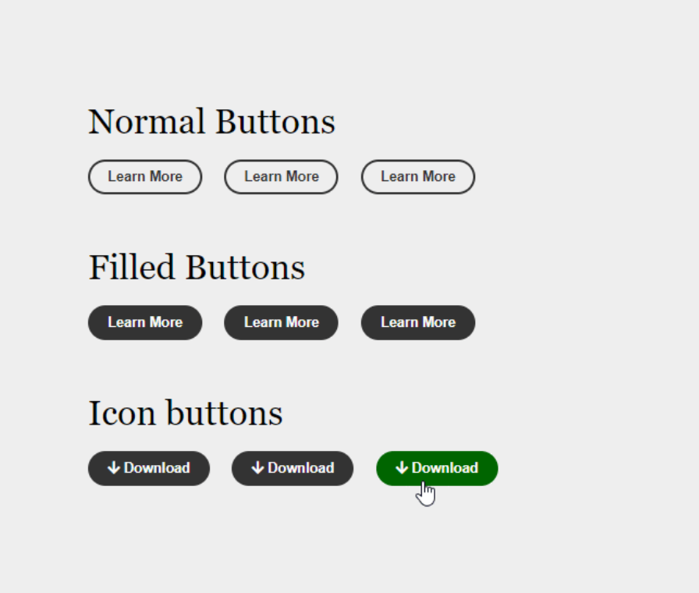

## Fonts Speciment – Great Vibes + Raleway

Create a web page like the following:

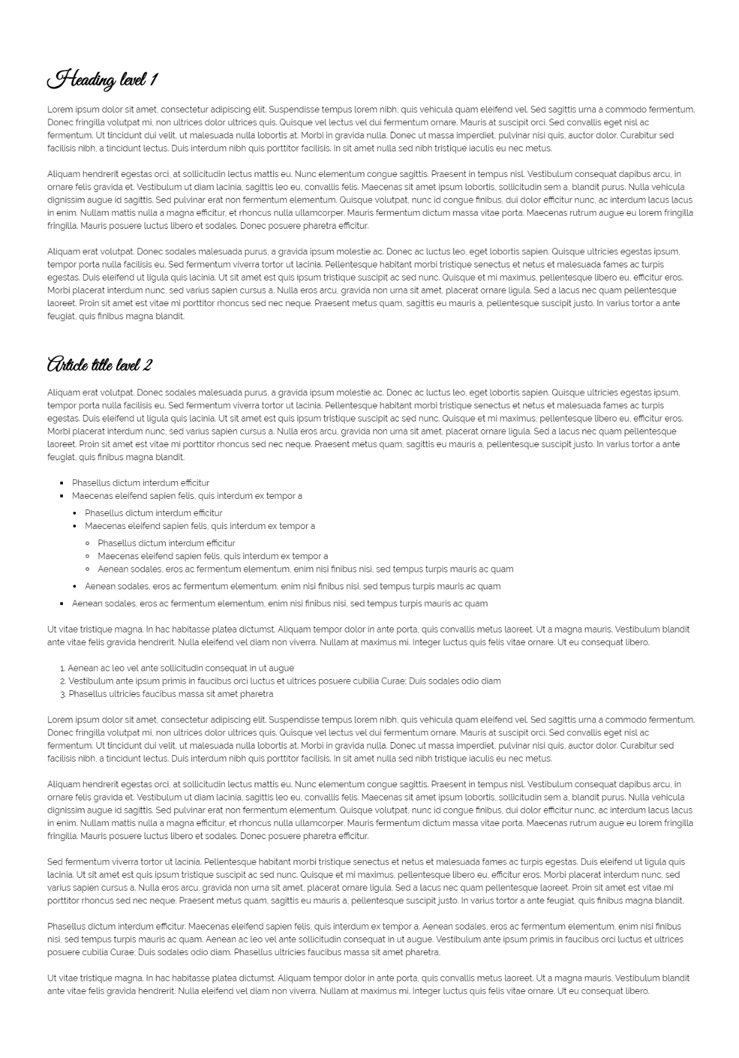

## Contrasting Colors

Create a web page like the following:

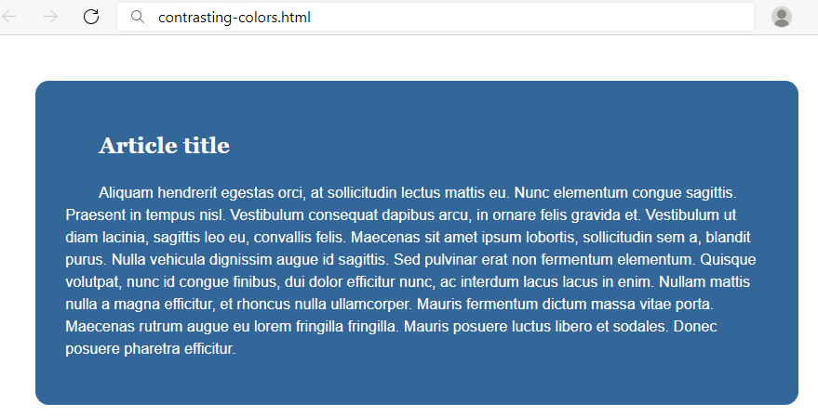

## The Making of a CSS Font

Create a web page like the following:

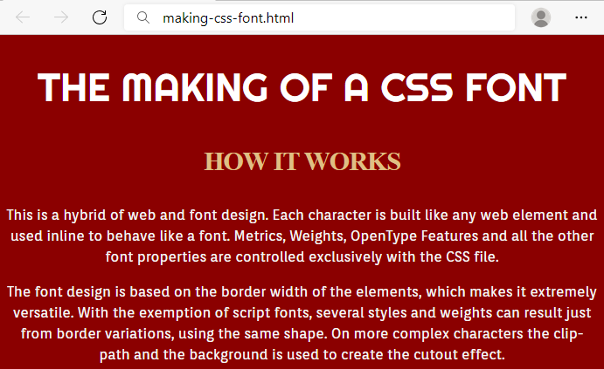

## Font Awesome Icons

Create a web page like the following:

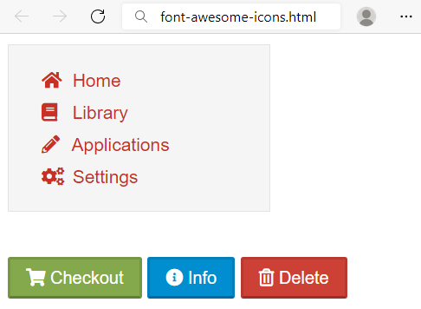

## Icon Font Buttons

Create a web page like the following:

